Task 1: To Create Process Escape Sequences, Handle Escaped Spaces, Escape Special Symbols, Preserve Characters, Validate Parser Output, Test Complex Inputs.
Code:
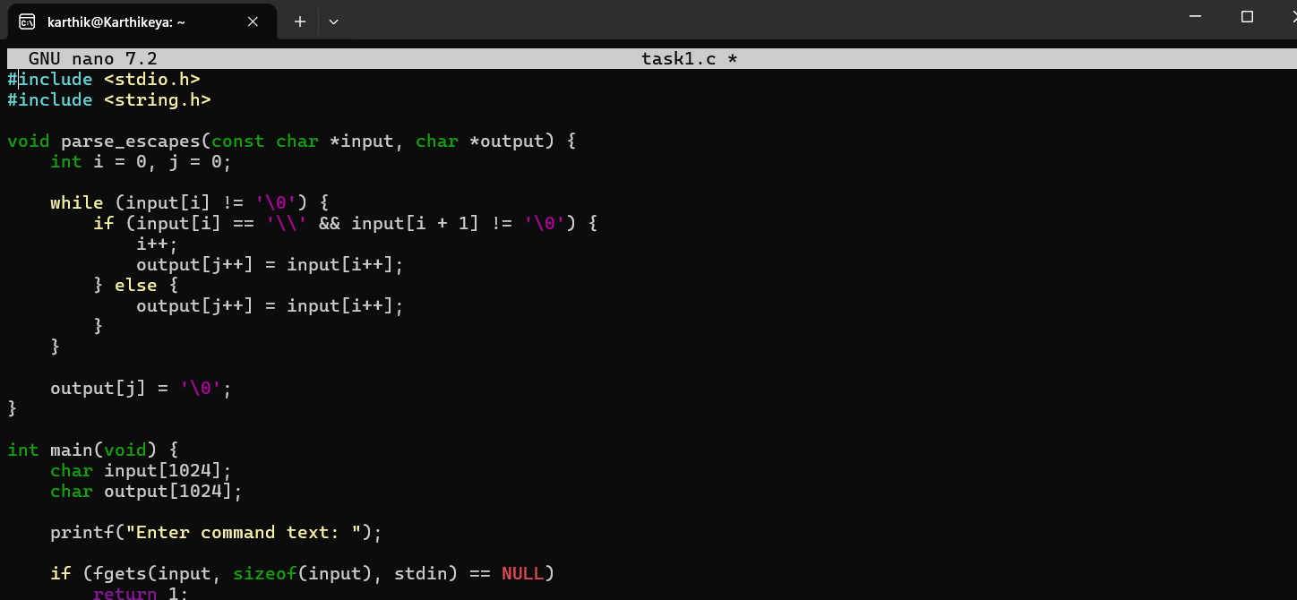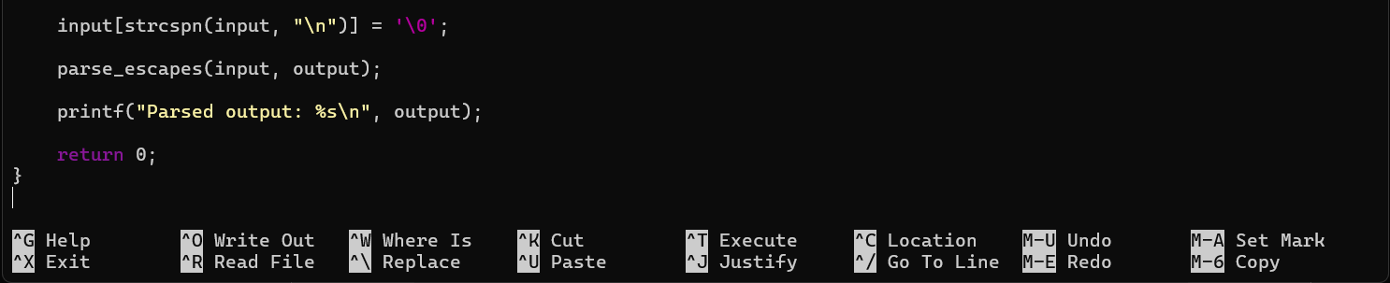

Output:
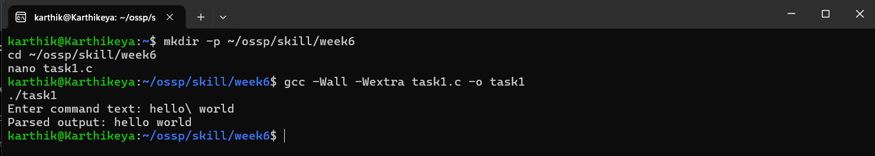

Task 2: To Create Child Processes, Execute Programs, Handle Execution Errors, Pass Arguments, Manage Parent Process, Test Command Launching.
Code:
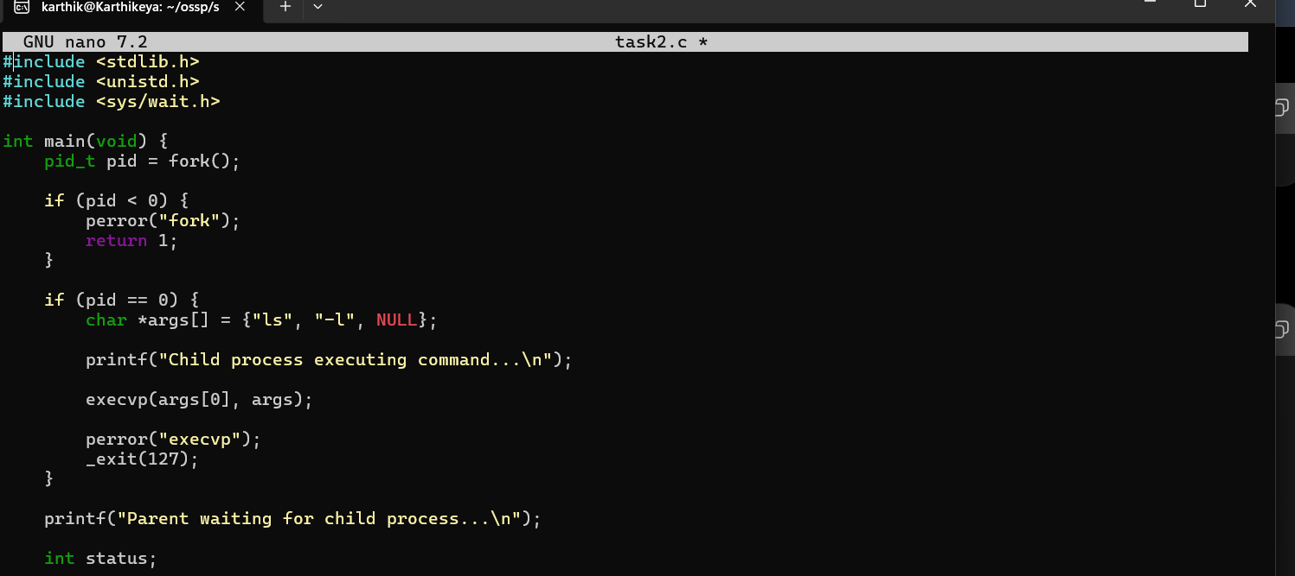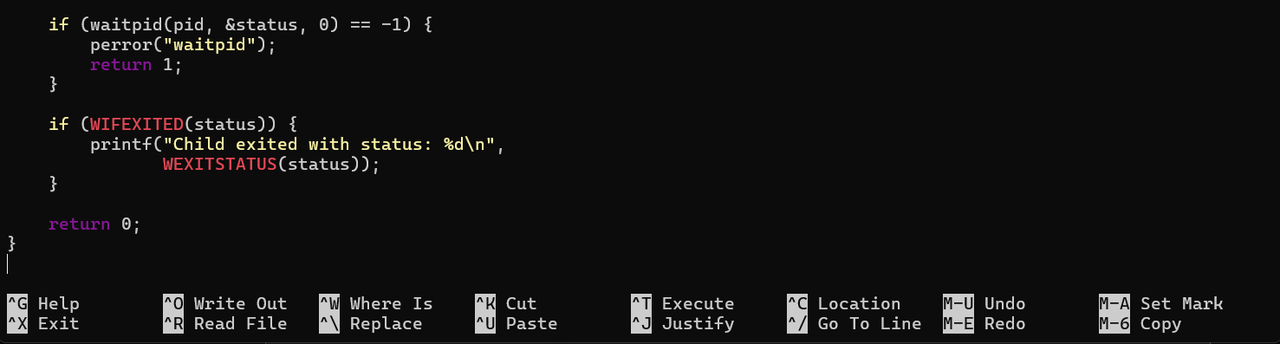

Output:
